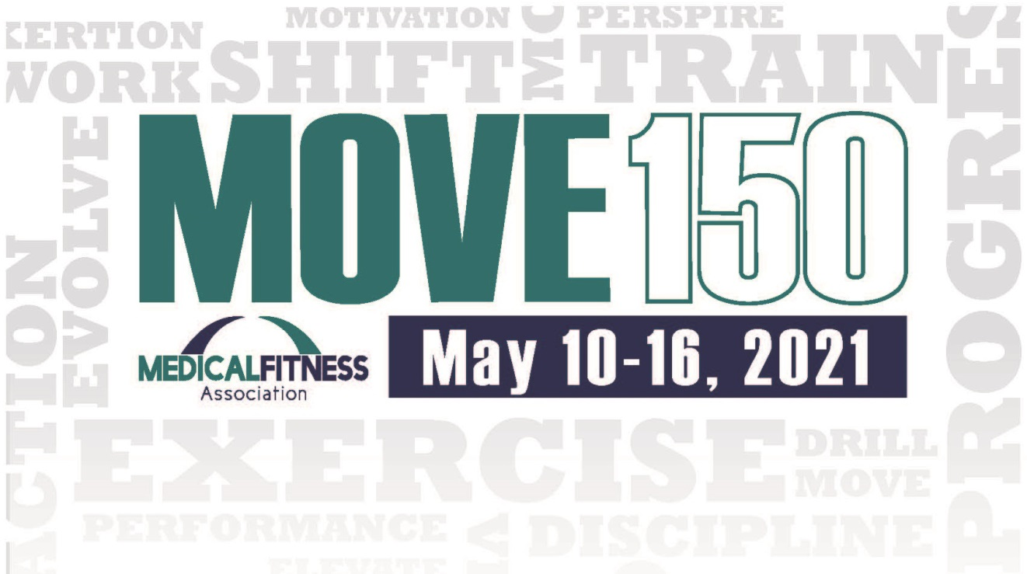

**2021 Medical Fitness Week Challenge**

**Congratulations! You have registered your facility to participate in the MOVE150 Challenge. The instructions below will aid in implementing the program in your facility. This program can be customized for different audiences, equipment or classes offered. We hope this program increases the activity levels of your facility members and community throughout the week.**

**How the program works:**

1. Documents provided – A template for a flyer and activity card are provided. Both can be customized! Insert your logo and alter the activity card to include specific classes, equipment or programs your facility offers. You may want to create more advanced rows/columns to engage experienced exercisers.
2. Activity Card - Each row or column on the activity card should add up to *at least* 150 minutes. Many may add up to more than 150 minutes. You may want to identify some rows for novice and advanced participants. Like a bingo card, participants will choose a row or column to complete. Each square represents one day.
3. Prizes – Determine if every participant gets a prize or if all who finish will be entered for a prize drawing.
4. Fees – Determine if your program is going to be free or have an associated fee.
5. Charity – If you are raising money for a charitable cause, revise the flyer to include that information.
6. Participants – You have several options for who can participate:
   1. You may have one MOVE150 card that is only for your members and create a community MOVE150 card for home and outdoor activities.
   2. Some may choose to open their facility to the community for the week so everyone has access to classes and equipment and use one card for all.
   3. You may also choose to offer the MOVE150 Youth Card to your local elementary schools and businesses.
7. Go to the MFA website www.medicalfitness.org to download flyers, Move150 logos, and the Move150 activity cards.
8. Track your participation to share your results with MFA. Join other facilities by sending Medical Fitness Week Move150 updates and photos to #MFWMove150