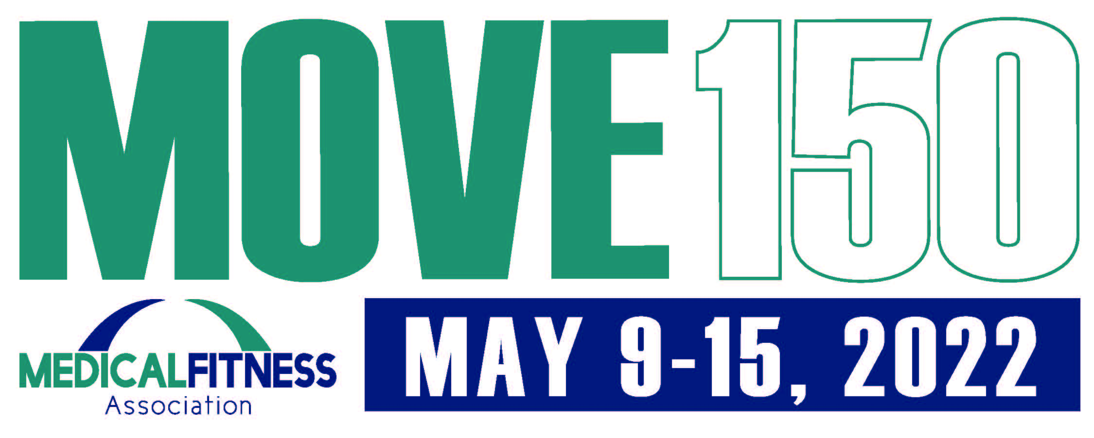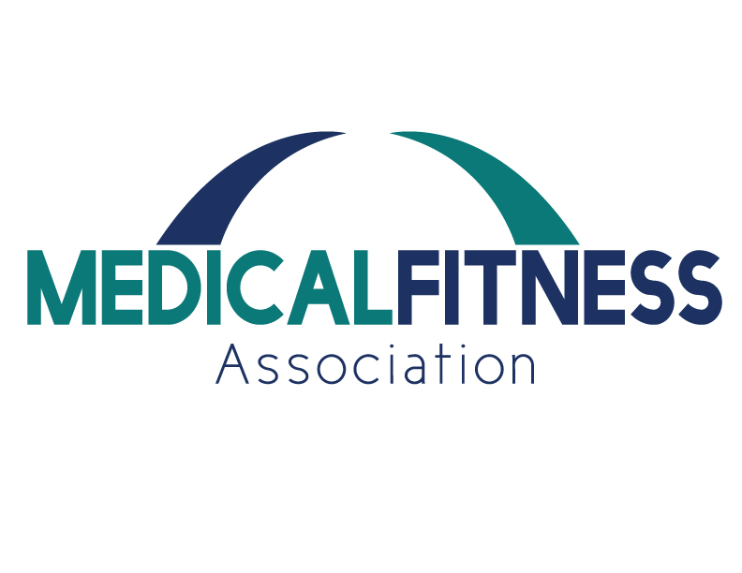

Turn in completed card at [insert location here] by May 19, 2022.

[insert facility information and logo here]

**2022 Medical Fitness Week Challenge Card**

|  |  |  |  |  |  |  |
| --- | --- | --- | --- | --- | --- | --- |
| M | O | V | E | 1 | 5 | 0 |
|  |  |  |  |  |  |  |
|  |  |  |  |  |  |  |
|  |  |  |  |  |  |  |
|  |  |  |  |  |  |  |
|  |  |  |  |  |  |  |
|  |  |  |  |  |  |  |
|  |  |  |  |  |  |  |

Name: _____________________ Phone: ____________ Email: ______________________

Your goal is to move at least 150 minutes this week!

Complete one row or column of activity challenges. Exercises do not have to be completed in order.

**Complete one square per day and date box when complete.**