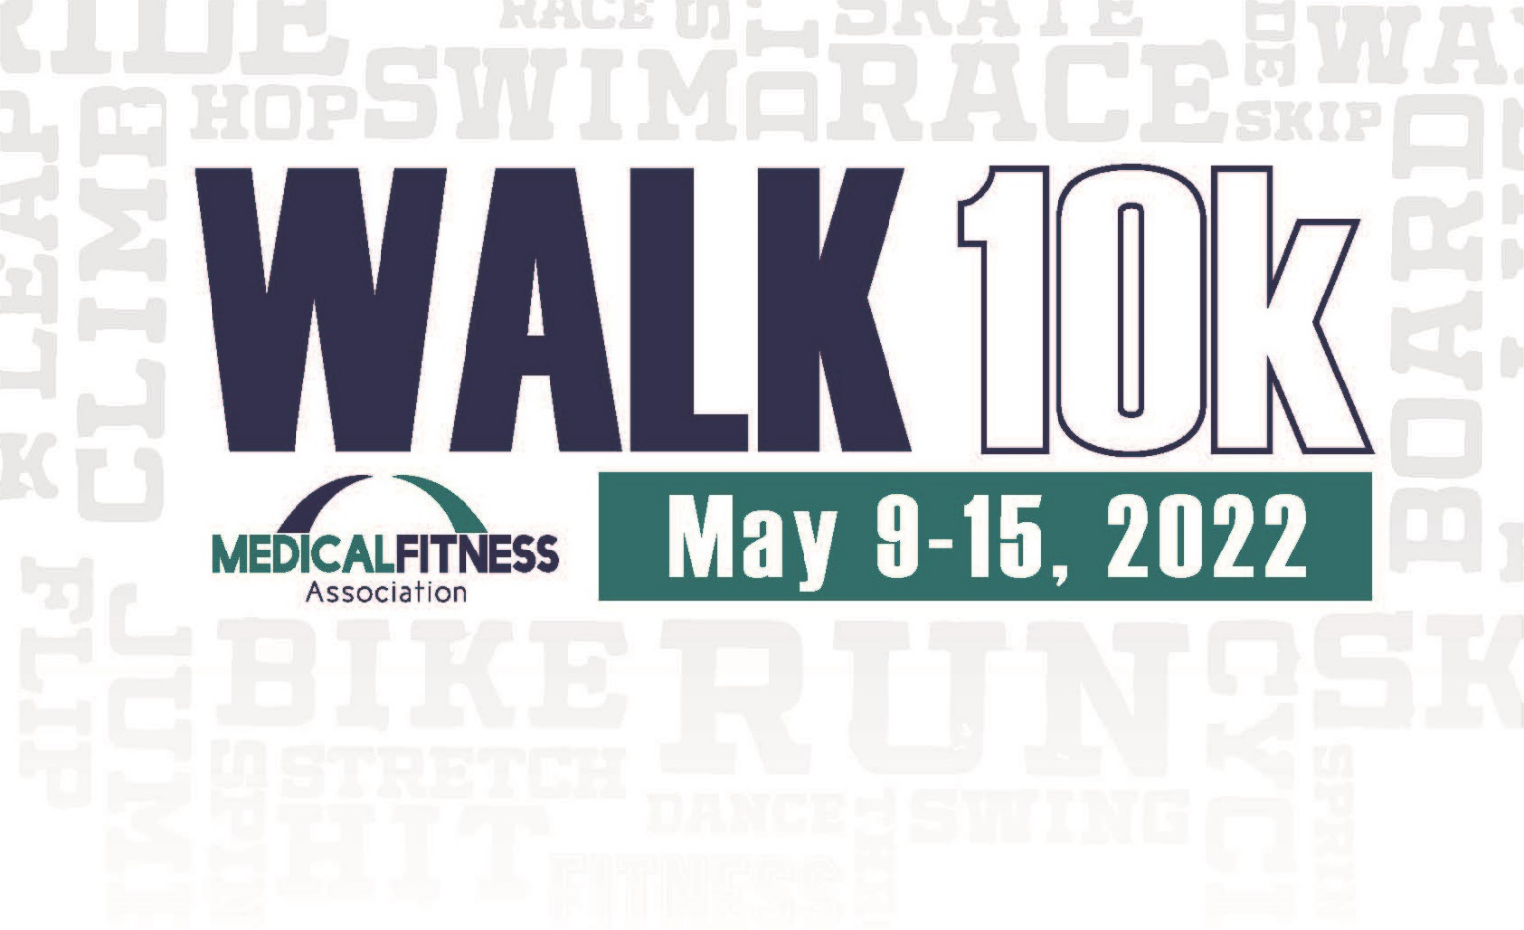

Turn in completed card at [insert location here] by May 19, 2022.

Thank you for your participation.

[Insert facility details/logo here]

|  |  |  |
| --- | --- | --- |
| **Monday, May 9 - Total Steps** |  | |
|  | | |
| **Tuesday, May 10 - Total Steps** |  | |
|  | | |
| **Wednesday, May 11 - Total Steps** |  | |
|  | | |
| **Thursday, May 12 - Total Steps** |  | |
|  | | |
| **Friday, May 13 - Total Steps** |  | |
|  | | |
| **Saturday, May 14 - Total Steps** |  | |
|  | | |
| **Sunday, May 15 - Total Steps** |  | |
|  | | |
| **Total Steps for the WALK10k Week** | |  |

Name: _____________________ Phone: ________________ Email: _______________________

The goal of the WALK10k Challenge is to increase the number of steps taken daily to 10k a day throughout Medical Fitness Week. Please wear your pedometer or use your wearable device from the moment you wake up, to the moment you go to bed. At the end of the day, enter your total steps below. Reset your pedometer/wearable device in preparation for the next day.