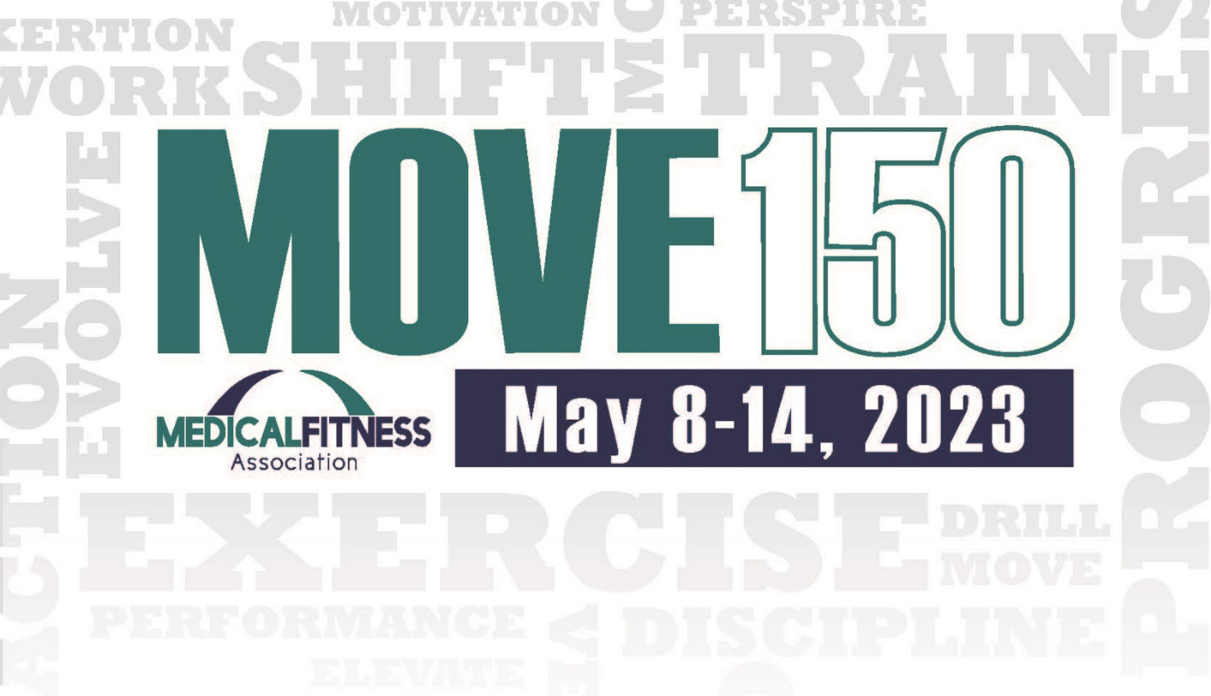

**2023 Medical Fitness Week Challenge**

**Take the challenge & be ready to MOVE!**

**Welcome to the National Medical Fitness Week MOVE150 Challenge! The American College of Sports Medicine encourages us to be physically active at least 150 minutes per week.**

***Join the fun by completing your MOVE150 card.***

**HOW TO PARTICIPATE**

1. Pick up your Move150 card at [insert location]
2. Complete a row or column of activity challenges, writing in the date completed
3. Exercises do not have to be completed in order, as long as the row/column is complete at the end of the week (be sure to date each box upon completion). Complete one box per day.
4. Submit your completed Move150 card to [insert location] by [insert date]

**PRIZES**

Participate and you can win

[Insert Prize]

[Insert Prize]

[Insert Prize]

Winners will be notified by [insert notification method phone, email etc.]

Prizes can be claimed [insert location]

[insert facility details/logo here]