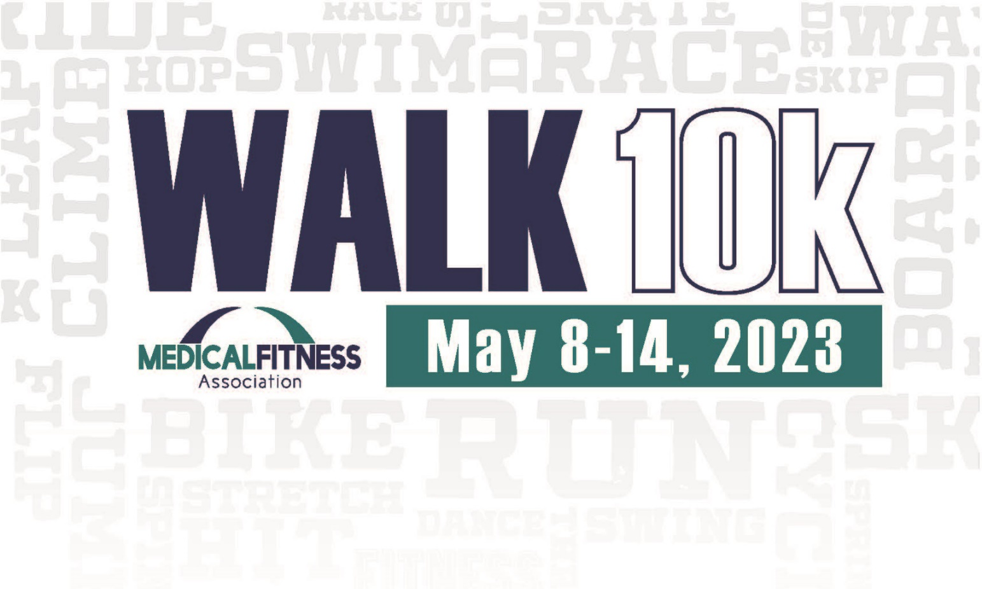

**2023 MFA Week Challenge**

[Insert facility details/logo here]

**Welcome to the Medical Fitness Week WALK10k Challenge! 10,000 steps a day (the equivalent of walking about five miles) is safe and effective whether you’re already active or just getting started. A good goal is to increase your daily steps each week by 500 per day until you are normally achieving 10,000 steps a day. Join the fun by participating in the WALK10k Challenge and take a step towards a healthier lifestyle!**

1. Pick up your pedometer and log sheet at [insert location].
2. Get accustomed to wearing your pedometer prior to starting the program. The best location is on your waist band in the midline of either thigh.
3. The first official day of the program is Monday, May 8th. Begin wearing your pedometer!
4. At the end of each day, enter your total daily steps on your log sheet, and then reset your pedometer to be prepared for the next walking day!
5. Continue to follow this process throughout the week, from Monday, May 8th through Sunday, May 14th.
6. Submit your completed WALK10k log sheet to [insert location] by [insert date]

**Prize Information**

* Participate and you can win

[Insert Prize]

[Insert Prize]

[Insert Prize]

* Winners will be notified by [insert notification method phone, email etc.]
* Prizes can be claimed [insert location]